**CURICULUM VITAE** 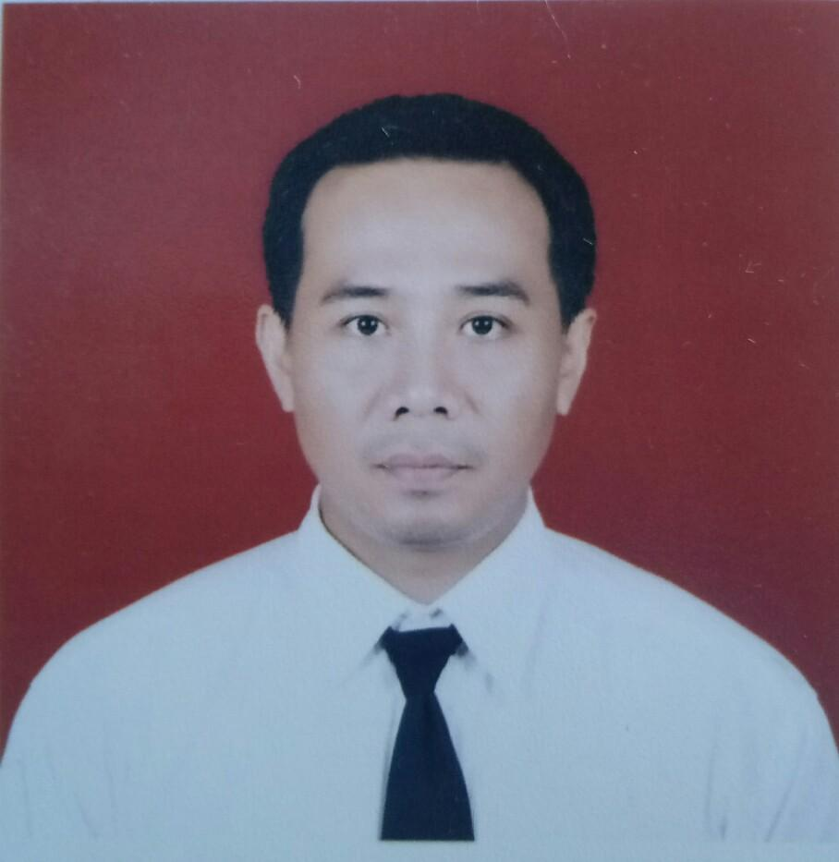

**PERSONAL DATA**

|  |  |  |  |
| --- | --- | --- | --- |
| **Full name** | Kenang Sismani | **Marital statue** | Married |
| **Date of birth** | April 11th 1980 | **Place of birth** | Pati/Central Java |
| **Nationality** | Indonesia | **Religion** | Moslem |
| **Home stay** | Penjawi street 8/3 | **Phone** | +6281326538951 |
|  | Randukuning-Pati 59111 Central Java | **Email address** | [kenangsismani@yahoo.co.id](mailto:kenangsismani@yahoo.co.id) |
| **Last education** | Diploma 3 Tehnik machine/Maritime academy |  | [Kenang1980@gmail.com](mailto:Kenang1980@gmail.com) |

**CERTIFICATE OF COMPETENCY**

|  |  |  |
| --- | --- | --- |
| Engineer Officer Class III Management | 6200114809S30317 | Jakarta,March 14th 2017 |
| Endorsment of Certificate class III Management | 6202011048TC0315 | Jakarta,March 14th 2017 |
| Diploma 3 Technik Machine | 216/T02 | Semarang,Jan 17th 2002 |
| Transkrip GPA | 216/T02 | Semarang,Jan 17th 2002 |

**CERTIFICATE OF PROVICIENCY**

|  |  |  |  |  |
| --- | --- | --- | --- | --- |
| **No** | **Grade STCW 95** | **No. Of Certificate** | **Date of Issue** | **Place of Issue** |
| 1 | BST Revalidation | 6200114809010316 | April,12nd 2016 | PIP Semarang |
| 2 | PSCRB Revalidation | 6200114809040316 | April,26th 2016 | PIP Semarang |
| 3 | AFF Revalidation | 6200114809060316 | May 17th 2016 | PIP Semarang |
| 4 | MEFA Revalidation | 6200114809070316 | May 31st 2016 | PIP Semarang |
| 5 | TFC Cert. | 6200114809090303 | Jan 14th 2003 | PIP Semarang |
| 6 | ISM Code Cert. | 21.413/Ism/PIP.SMG/VII/04 | JULY 26TH 2006 | PIP Semarang |
| 7 | MC on board ship | 6200114809080316 | June 15th 2016 | PIP Semarang |
| 8 | SAT Cert. | 6200114809310316 | August 10th 2016 | PIP Semarang |
| 9 | ERRM Revalidation | 6200114809270317 | Sept,26th 2016 | PIP Semarang |
| 10 | Seafarers with Designated Security Duties | 6200114809320316 | Sept,14th2016 | PIP Semarang |
| 11 | SSO Revalidation | 6200114809240316 | July,19th 2016 | PIP Semarang |

**DOCUMENTS**

|  |  |  |  |  |  |
| --- | --- | --- | --- | --- | --- |
| **No** | **Type** | **Number** | **Date of Issue** | **Expired Date** | **Place of Issue** |
| 1 | Passport | B 2342677 | Feb,16 2016 | Feb16,2021 | KBRI Hongkong |
| 2 | Seaman Book | W 043189 | May,272012 | June 27,2021 | Semarang |
| 3 | Yellow fever book | F00-0179662 | Oct,23 2017 | Oct,10 2022 | Jakarta |
| 4 | MCU OGUK | OGUK/2018/2503 | Oct 21,2019 | Oct 21,2021 | Medica OHC Jakarta |
| 5 | BOSIET-EBS/Opito | 89815700310719002 | July 31,2019 | July 30,2023 | PT.Lautan Tenang Jaya |

**DETAILS OF SEA EXPERIENCES**

|  |  |  |  |  |  |  |  |  |
| --- | --- | --- | --- | --- | --- | --- | --- | --- |
| **No** | **Name of Ship Flag** | **Kind of Ship/Area Operation** | **DWT** | **Engine type & HP** | **Sign On/Off**  **Duration** | **Rank** | **Company** | **Job Discriptions** |
| 1 | MV. Maju Jaya | Container/ Indonesia | 1980 | MAN  2DLB51  2x750 | July 13,2002  Sept24,  2002 | Oiler | Johan Shipping Malaysia | -Assist engineer maintenance and repaire machinery and all equipment in engine room and maintain log book.  -Watch keeping in Engine room |
| 2 | KM.Paulina | Cargo/  Indonesia | 2300 | Mitsubishi  6DS58  2x750 | Dec18,  2002  August  20,2003 | Cadet | PT.JBM Surabaya  Indonesia | -Cadet in Engine room and familirization crew list.  -Assist engineer and chief engineer and support all crew and deck equipment.  -Watch keeping with engineer duty |
| 3 | TB.Elvin 1 | Tugboat/  Indonesia | 220 | Cummins  14P2V  2x350 | Dec,152004  Febr,32006 | Chief Engineer | PT.UUBS  Banjarmasin-Indonesia | -Maintenance,operation and repaire machinery and equipments in engine room and deck.  -Maintain log book engine room.  -safety first,keep clean engine room and supervise engineer and rating |
| 4 | SV.Osam Leopard | Supply Vessel  /Sea of Java-Indonesia | 478 | Fuji Diesel Engine  GM233C  2x1000 | March03,2006  March292007 | Second engineer | PT.Rig Tender Indonesia | -Maintenance,operation and repaire machinery and equipments in engine room and deck.  -Assist Chief engineer,maintain log book and keep clean.  -Assist Chief engineer maintain log book E/R and spare part and tidy up tools in engine room  -Handle Generator and assist C/E and deck crews. |
| 5 | TB.Entebe Mega Star 53 | Tug Boat  /Foreign going | 291 | Cummins  KTA50  2x1400 | Dec,082007  Sept,10  2008 | Second Engineer | PT.DBS  Banjarmasin-Indonesia | -Maintenance,operation and repaire machinery and  equipments in engine room and deck.  -Assist Chief engineer and Maintain log book engine room.  -safety first and supervise junior engineer and rating |
| 6 | MV.Amarco Tiger | Offshore Workboat  /Labuan-Malaysia | 1512 | Industrie Diesel  2x1100 | August  19,2009  Nov,112009 | Third Engineer | Amarco Sdn Bhd Brunei | - Maintenance,operation and repaire machinery and equipments in engine room and deck.  -Assist senior engineer and C/E for maintain log book,safety and implementation work safety in engine room and deck  -Report to senior engineer/Chief Eng for implementation daily working and supervisor engine rating. |
| 7 | GSF.EXPLORER | DrillShip  /Sulawesi Strait- Indonesia | 28768 | Nordberg  And  EMD  5x4900  4x3070 | August  02,2010  Dec22  2010 | Assist Third Marine Engineer | Trans Ocean | -Assist senior engineer and chief engineer for maintenance,operation and repaire machinery and equipments on Rig  -Report to senior engineer if any machinery is malfunction and keep engine room keep clean.  -Assist and maintenance senior engineer and mechanic department if any malfunction in Rig floor equipments.  -Work team and safety firts and support each other department on Rig.  -Pre meeting every morning and weekly safety meeting for maintain and avoid accident when working.  -weekly Fire drill and abandon ship.  -Daily check of machinery,generator,pumps,compressor and all equipments in engine room,rig floor and accomodation.  -Support all department on rig and responsibilty on duty. |
| 8 | Petrogas III | AHTS  /Sea oj Java-Indonesia | 1640 | Cummins  2x3500 | Oct,082011  March09,2012 | Third Engineer | Pertamina Jakarta | - Maintenance,operation and repaire machinery and equipments in engine room and deck.  -Assist senior engineer and C/E for maintain log book,safety and implementation work safety in engine room and deck  -Report to senior engineer/Chief Eng. |
| 9 | Supreme Energy 1 | Crane Barge  200T  /Labuan-Malaysia | 4436 | Caterpilar  3x550 | June,042012  May,09  2013 | Chief Engineer | Thome Offshore  Singapore | -Maintenance,operation and repaire machinery and equipments in engine room and deck.  -Maintain log book engine room.  -safety first,keep clean engine room and supervise engineer and rating  -Assist Barge master and Supervisor all crews and maintenance of Crane crowler sumitomo 100T.  -Obey all regulation contractor,local and international |
| 10. | ENSCO 85 | Jack up Conventional  /Sea oj Java-Indonesia | - | EMD  (12-645-8)  3x1650 | June,29 2013 Dec,28  2013 | Mechanic | ENSCO | -Assist Chief Mechanic for maintenance,operation and repaire machinery and equipments on Rig  -Report to senior Mechanic if any machinery is malfunction and repaire  -Maintain log book and engine room keep clean.  -Assist senior Mechanic for maintenance and repaire mechanic department if any malfunction in Rig floor equipments department.  -Work team and safety firts and support each other department on Rig.  -weekly safety meeting for maintain and avoid accident when working.  -weekly Fire drill and abandon ship.  -Daily check machinery,generator,pumps,compressor and all equipments in engine room,rig floor and accomodation. |
| 11. | Hakuryu 11 | Jack up Drilling  /Vietnam | - | Caterpilar C-175  5x2650 | Jan,152014 – June,28 2014 | Assist mechanic | Japan Drilling Company | -Assist senior Mechanic and chief Mechanic for maintenance,operation and repaire machinery and equipments on Rig  -Report to senior mechanic if any machinery is malfunction and keep engine room keep clean.  -Assist and maintenance senior Mechanic for maintenance and repaire mechanic department if any malfunction in engine room and Rig floor equipments.  -Work team and safety firts and support each other department on Rig.  -Pre meeting every morning and weekly safety meeting for maintain and avoid accident when working.  -weekly Fire drill and abandon ship.  -Daily check machinery,generator,pumps,compressor and all equipments in engine room,rig floor and accomodation.  -Support all departments on the Rig.  -Responsibilty on duty and obey all regulation of Contractor,Client and Internatioanal |
| 12 | Tat Hong 823 | Work Barge 400T  /Bridge Project construction-Hongkong- Macau water | 5600 | Caterpillar  4x350 | Oct 272014-July,08  2017 | Chief Engineer | Tat Hong Offshore and Marine Singapore | -Maintenance,operation and repaire machinery and equipments in engine room and deck.  -Maintain log book engine room.  -safety first,keep clean engine room and supervise engineer and rating  -Assist Barge master and Supervisor all crews and maintenance of Pedestal Crane Favco 350T  -Obey all local and international regulation |
| 13 | Dong Pi 8 | Work Barge  /Bridge Project Construction-Xinmen Taiwan | 5800 | MERCEDES OM 442 LA  2000 Hp | Nov 27  2017-  Feb 28,2018 | Chief Engineer | Dong Pi Construction co ltd Taiwan | -Maintenance,operation and repaire machinery and equipments in engine room and deck.  -Maintain log book engine room.  -safety first,keep clean engine room and supervise engineer and rating  -Assist Barge master and Supervisor all crews and maintenance of DEMAG Crane CC4000 |
| 14 | Maersk Viking | Drillship | 69468 | DOSAN-MAN DIESEL  16V32/40  6x@7248  KW | 27 Oct  2019-  13 Nov 2019 | ERR/  Engine Room Responsible | Maersk Drilling | Conducting the engine watch and informing technical Section leader immediatelly about abnormal instrument reading or failure symptoms detected on critical equipment.  Responsibility is also responsible for maintenance for daily operation and maintenance of the machinery. |